# CS 255 System Design Document

Brooklen Ashleigh

June 15th, 2023

## UML Diagrams

UML Use Case Diagram

### UML Activity Diagrams

### 

### 

### UML Sequence Diagram

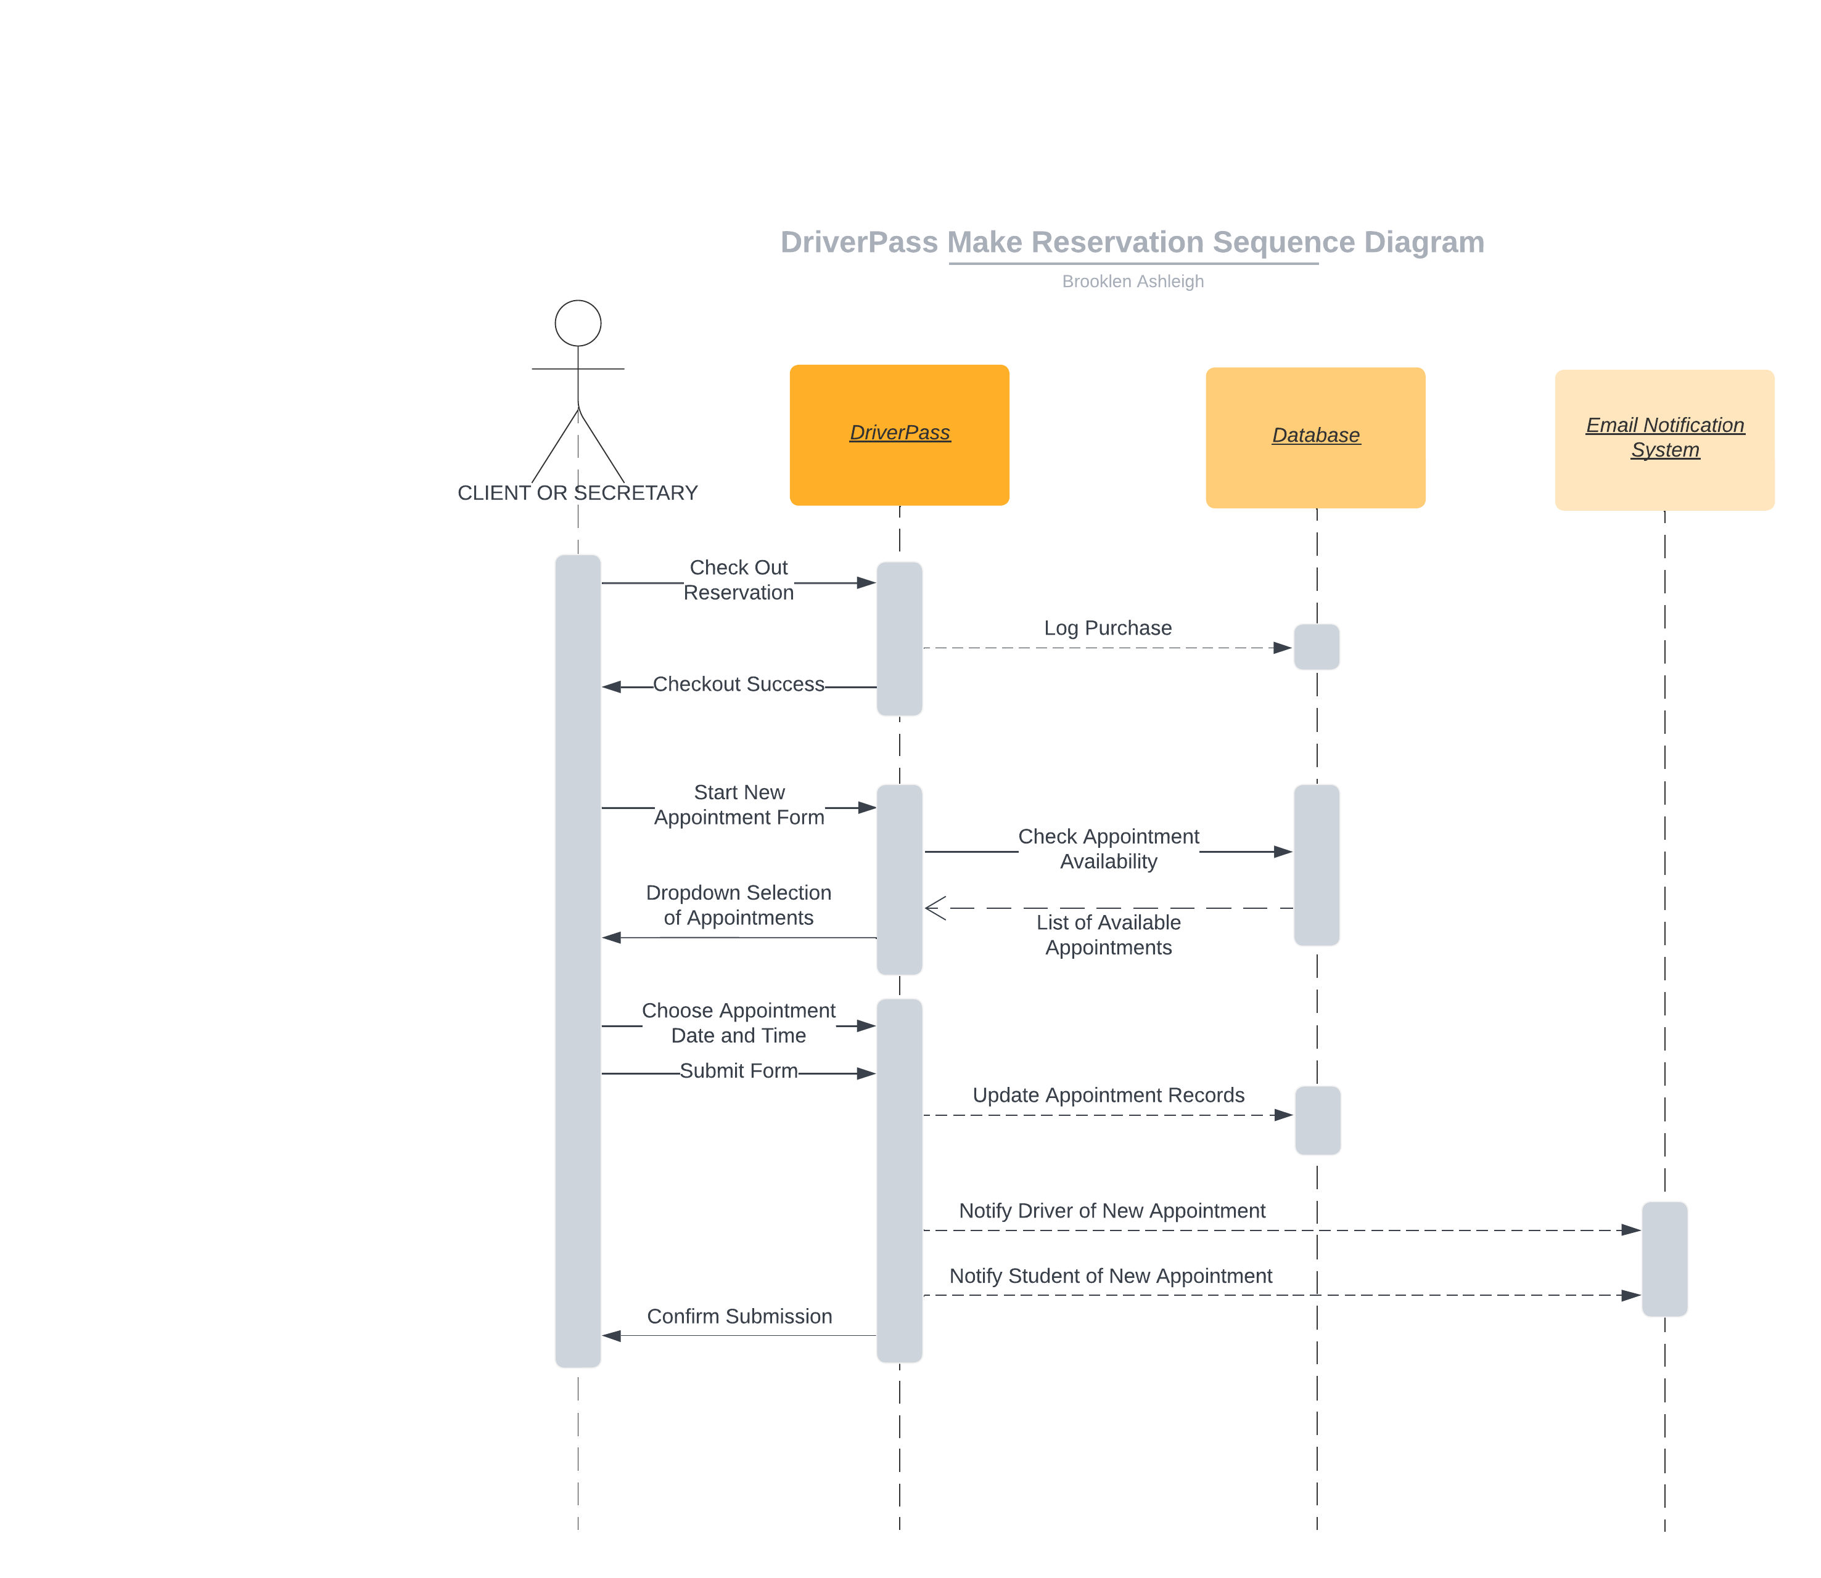

### UML Class Diagram

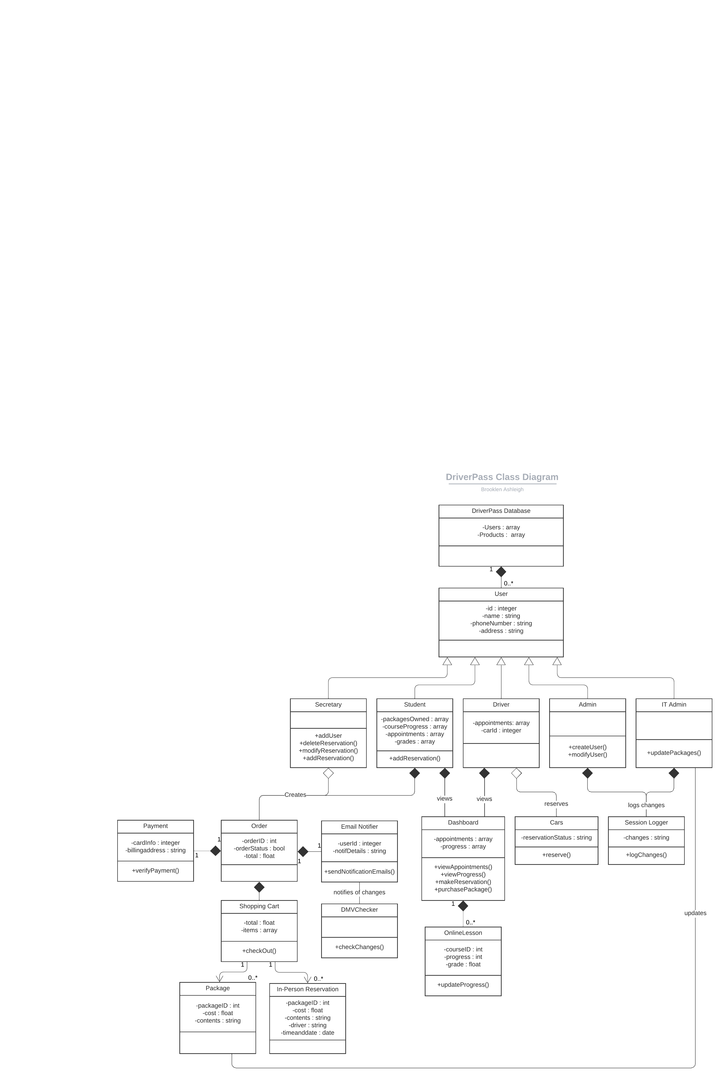

## Technical Requirements

Due to its always on, always available nature, the DriverPass system requires a cloud-based approach utilizing a database and Content Management System that will be available for editing by typical user roles: Admin, IT Admin, and Secretary. These roles will have permissions to make necessary edits to site content and users. A Content Management system will make editing database entries simple for non-technical users, while still ensuring the system is robust and easy to manage.

The system database will keep detailed entries for each system user, including which packages they’ve purchased, when their upcoming appointments are, their personal information, and the progress they have made in their courses. The database structures these client users based on distinct IDs, ensuring accuracy and consistency across the platform.

The system will allow the user to purchase packages and create reservations from their website portal, but clients can also be assisted by the Secretary User, who has permissions to create and modify reservations for them. The system will then coordinate appointments between its Student and Driver users.

Security will be maintained by the cloud-based provider, Amazon Web Services for example, which will automatically handle backups, authentication, and security, while also ensuring good performance and system uptime. The system shall serve lessons to the client with minimal performance degradation or interruption.